1.4 Matrices and Matrix Operations
Rectangular arrays of real numbers arise in contexts other than as augmented matrices for linear systems. In this section we will begin to study matrices as objects in their own right by defining operations of addition, subtraction, and multiplication on them (not on their rows).
The following rectangular array with three rows and seven columns might describe the number of hours that a student spent studying three subjects during a certain week:
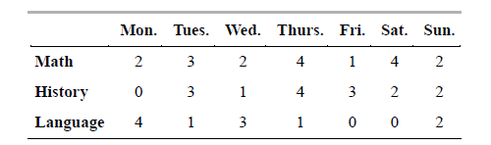
If we suppress the headings, then we are left with the following rectangular array of numbers with three rows and seven columns, called a “matrix”:
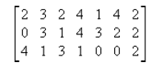
Definition: A matrix is a rectangular array of numbers. The numbers in the array are called the entries in the matrix.
Examples:
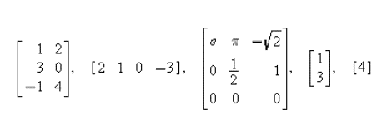
Note: A matrix with only one column is called a column vector or a column matrix, and a matrix with only one row is called a row vector or a row matrix.
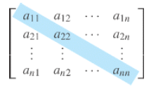
A matrix A with n rows and n columns is called a square matrix of order n, and the shaded entries are said to be on the main diagonal of A.

Matrix Operations
- Two matrices are defined to be equal if they have the same size and their corresponding entries are equal.
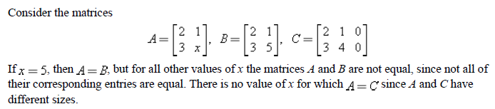

- If A and B are matrices of the same size, then the sum A+B is the matrix obtained by adding the entries of B to the corresponding entries of A, and the difference A – B is the matrix obtained by subtracting the entries of B from the corresponding entries of A. Matrices of different sizes cannot be added or subtracted.
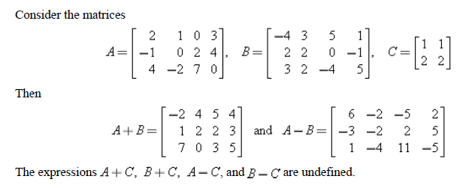
- If A is any matrix and c is any scalar, then the product cA is the matrix obtained by multiplying each entry of the matrix A by c. The matrix cA is said to be a scalar multiple of A.
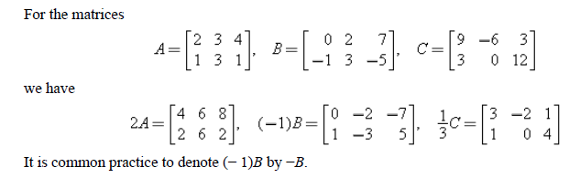
- If A is an $m×r$ matrix and B is an $r×n$ matrix, then the product AB is the $m×n$ matrix whose entries are determined as follows: To find the entry in row i and column j of AB, single out row i from the matrix A and column j from the matrix B. Multiply the corresponding entries from the row and column together, and then add up the resulting products.
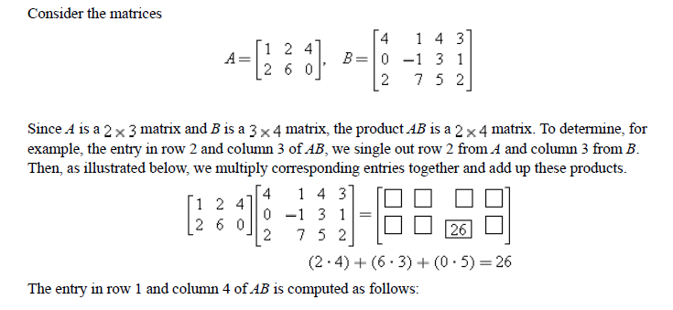
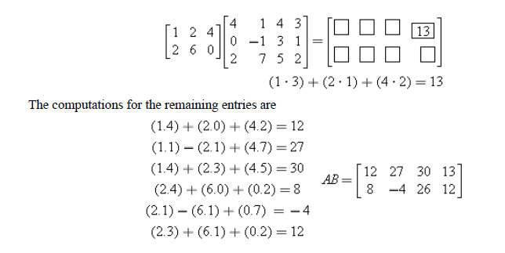
And hence,

- Matrix multiplication has an important application to systems of linear equations. Consider a system of m linear equations in n unknowns:
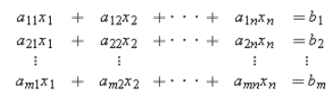

The matrix on the left side of this equation can be written as a product to give
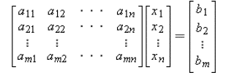
If we designate these matrices by A, x, and b, respectively, then we can replace the original system of m equations in n unknowns by the single matrix equation as
$$Ax=b$$
The matrix A in this equation is called the coefficient matrix of the system. The augmented matrix for the system is obtained by adjoining b to A as the last column; thus the augmented matrix is
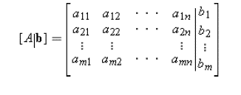
- If A is any $m×n$ matrix, then the transpose of A, denoted by $A^{T}$, is defined to be the $n×m$ matrix that results by interchanging the rows and columns of A; that is, the first column of $A^{T}$ is the first row of A, the second column of $A^{T}$ is the second row of A, and so forth.
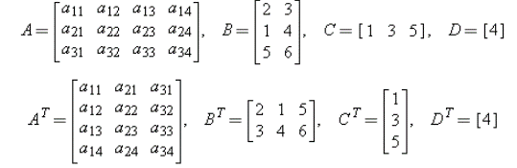
2.1 Determinants
WARNING: It is important to keep in mind that $det⁡(A)$ is a number, whereas A is a matrix.
If $A=\left[\begin{matrix}a & b \\ c & d\end{matrix}\right]$, the expression $ad-bc$ is called the determinant of the matrix A. This determinant is denoted by writing
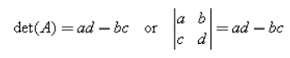
Cofactors of a matrix
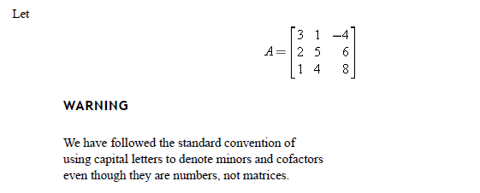
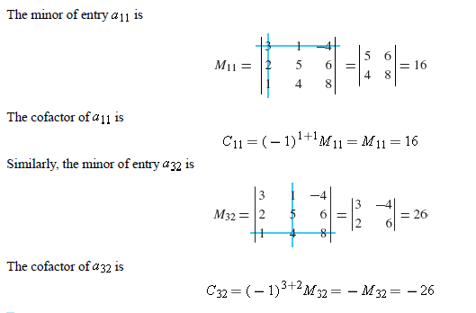

Definition
If A is an $n×n$ matrix, then the number obtained by multiplying the entries in any row or column of A by the corresponding cofactors and adding the resulting products is called the determinant of A, and the sums themselves are called cofactor expansions of A. That is:
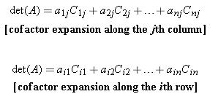
Example 3:
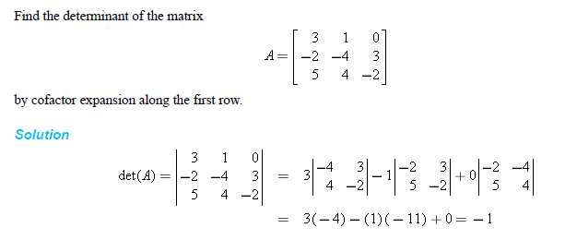

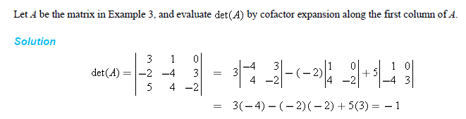
Remark:
Basic Properties of Determinants
Suppose that A and B are $n×n$ matrices and k is any scalar. Then:
- $det(A + B) ≠ det(A) + det(B)$
- $\det\left(kA\right)=k^{n}det⁡(A)$
- $\det\left(AB\right)=\det\left(A\right)det⁡(B)$
- A square matrix A is invertible if and only if $det⁡(A)≠0$.
- $\det\left(A^{-1}\right)=\frac{1}{a_{11}}\frac{1}{a_{22}}…\frac{1}{a_{nn}}$
- The points $P_{1}(x_{1},y_{1},z_{1}), P_{2}(x_{2},y_{2},z_{2}),$ $P_{3}(x_{3},y_{3},z_{3}),$ $P_{4}(x_{4},y_{4},z_{4}),$ are not coplanar if and only if the determinant
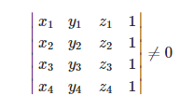
Remarks:
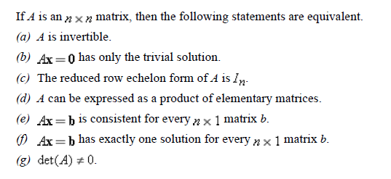
Work to do:
Q1(a)

(b) Check whether the points $\left(0,4,1\right), \left(4,0,0\right), (3,5,2)$ and $(2,2,5)$ lie in the same plane or not.
Q2. For any square matrices A, B , P with P invertible, Complete the following
det $A^{-1}$= ……………… det(AB)=……………… det(PA$P^{-1})=$………….
Q3. Let A and B be $3×3$ matrices with detA= 4 and det B = -3. Use properties of determinants to compute:

